Explore the Mystery of the Pyramid Diagonal: An Experiment You Can Do at Home
By Glen Dash, Glen Dash Foundation for Archaeological Research
For decades, archaeologists have speculated that the southeast corners of the Great Pyramid of Khufu and the second pyramid at Giza, Khafre, are aligned with the sacred city of Heliopolis. In a recent paper, we published new coordinates for the corners of these two pyramids. Now we can use that new data to test the hypothesis.
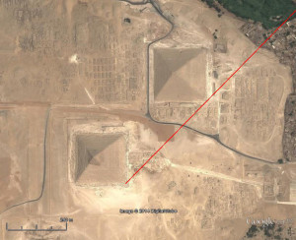
Figure 1: The "Pyramid Diagonal" connects the southeast corners of the pyramid of Khafre and the Great Pyramid of Khufu.
To do this yourself open Google Earth and search for the Pyramids of Giza. Zoom in on the southeast corner of the second pyramid, Khafre, which is readily discernible by its distinctive cap. Find the ruler tool at the top of the screen and by left-clicking on it, bring up the ruler menu. Set the map length units to kilometers. Place the cursor on the southeast corner of Khafre and left click once to anchor a line there. Move the cursor up and to the right to draw out a line past the southeast corner of the Great Pyramid of Khufu. The menu will give you the angle and distance. Try to set the angle 44.55 degrees, the calculated angle between the corners, or as close to that as you can get. Click once to set the east end of the line.
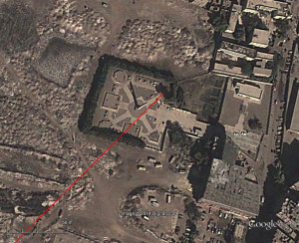
Figure 2: Extending the Pyramid Diagonal 24.1km to the northeast leads us to within a few meters of this obelisk at Heliopolis.
Now, using the zoom tool at the right of the screen, move out until the Nile appears. Using the arrow keys, center the Nile on the screen. You should be able to see the green area on either side of the Nile and some of the desert areas to the east and west. Grab the line you drew by moving the cursor to the east end of the line, left clicking on it, and while holding the button down, pulling out the line until it is 24.1 kilometers long, or as close to that as you can get, at an angle of 44.55 degrees (or so). Release the button to set the line. Now zoom way in on the east end of the line by using the keys at the right of the screen. Readjust the line’s length to 24.1km and its angle to 44.55 degrees.
If you did it right (it usually takes a couple of tries) you will have arrived at Heliopolis. The line passes just a few meters to the south and east of the obelisk of Senusret I, one of the few remaining vestiges of the great temples there.
The alignment raises important questions. Did the Egyptians intend for the pyramids of Giza and the temples at Heliopolis to be so aligned, or could this have been a result of chance? If they did intend the alignment, what were they trying to achieve? Aligning architectural monuments 24km apart to within .03 degrees, as they apparently did, is no mean feat. How could they have done that using only the tools they had? And why does the third pyramid at Giza, Menkaure, not share the same alignment?
Some of my other papers explore some of the answers to these question
About the author: Glen Dash has been surveying in Egypt for more than ten years. He directs the Glen Dash Foundation for Archaeological Research. You can read more about his work at http://www.DashFoundation.org.

